**<JobFile>**

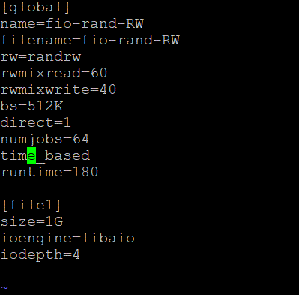

코드는 동일하고 numjobs: 1, 8, 15, 24, 48, 64, 98, 100 / bs: 8kb, 512kb 조절해가며 실험 진행하였습니다.

**<Result>**

-block size: 8kb-

|  |  |  |  |  |  |  |
| --- | --- | --- | --- | --- | --- | --- |
| Numjobs | Pem | | | Sdb | | |
| Read(MiB/s) | Write(MiB/s) | Latency(usec) | Read(MiB/s) | Write(MiB/s) | Latency(usec) |
| 1 | 592 | 395 | 28.30 | 142 | 94.7 | 174.90 |
| 8 | 414 | 276 | 370.45 | 257 | 171 | 670.03 |
| 16 | 350 | 233 | 926.50 | 260 | 173 | 979.73 |
| 24 | 320 | 213 | 1627.74 | 261 | 174 | 1545.91 |
| 48 | 434 | 289 | 1585.32 | 258 | 172 | 3769.99 |
| 64 | 326 | 217 | 4229.01 | 255 | 170 | 4651.64 |
| 96 | 466 | 311 | 4437.78 | 253 | 169 | 7078.79 |
| 100 | 365 | 243 | 6681.62 | 265 | 177 | 7460.40 |

-block size: 512kb-

|  |  |  |  |  |  |  |
| --- | --- | --- | --- | --- | --- | --- |
| Numjobs | Pem | | | Sdb | | |
| Read(MiB/s) | Write(MiB/s) | Latency(usec) | Read(MiB/s) | Write(MiB/s) | Latency(usec) |
| 1 | 1696 | 1131 | 691.60 | 264 | 175 | 4717.33 |
| 8 | 1433 | 953 | 6824.24 | 258 | 172 | 4443.96 |
| 16 | 710 | 473 | 28168.86 | 208 | 140 | 70273.47 |
| 24 | 709 | 474 | 43140.48 | 210 | 140 | 115230 |
| 48 | 718 | 480 | 83360 | 219 | 146 | 250610 |
| 64 | 740 | 518 | 93500 | 217 | 145 | 357380 |
| 96 | 879 | 587 | 140660 | 214 | 144 | 502830 |
| 100 | 880 | 587 | 141781 | 214 | 144 | 549910 |

**<Graph>**

-8kb-

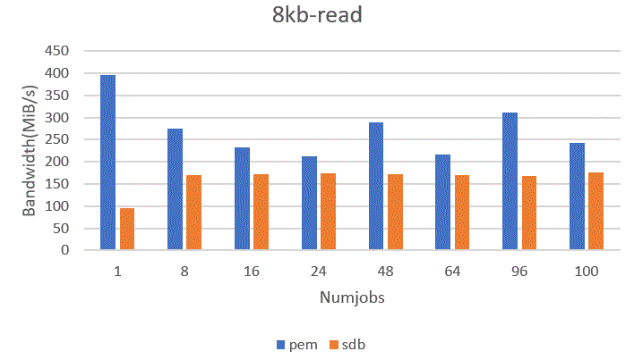

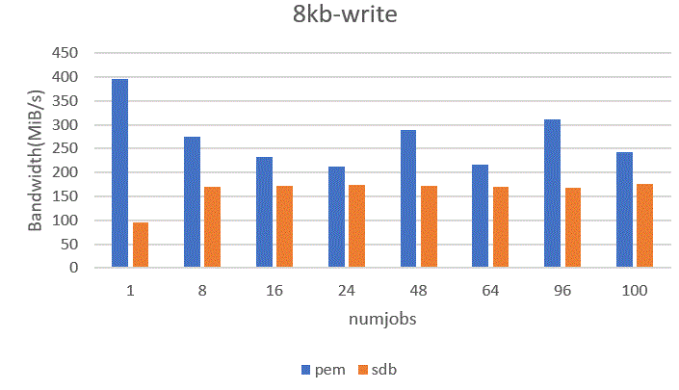

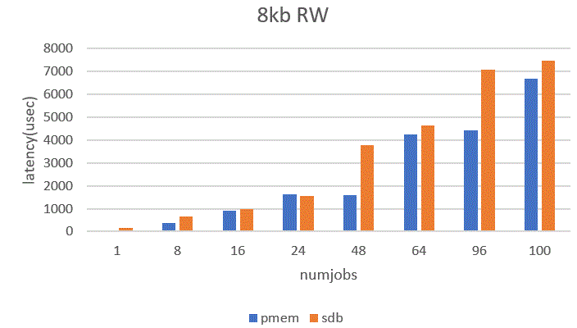

-512kb-

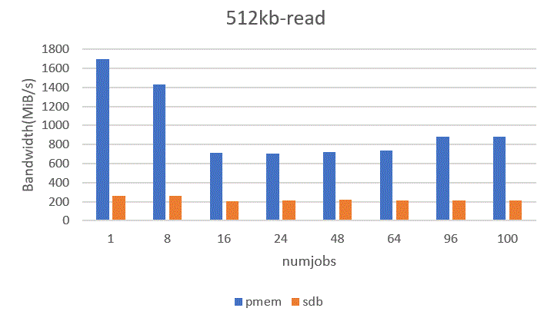

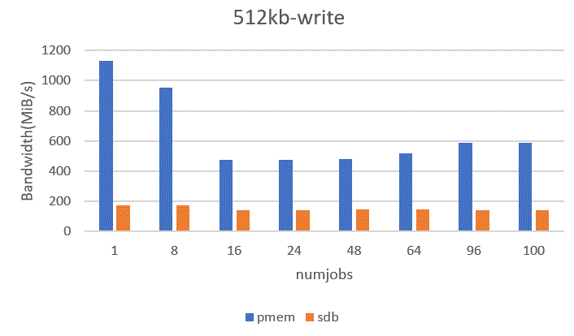

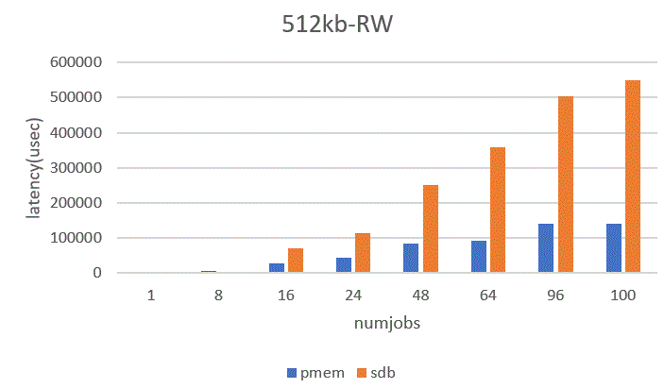

-> ext4 파일시스템으로 pmem, ssd의 RW에 대한 latency&bandwidth 측정결과 전반적으로 pmem의 성능이 더 뛰어난 모습을 보이고 있음